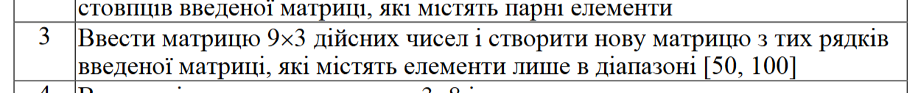

#include <iostream>

using namespace std;

float** input_matrix(int rows, int cols) {

float** matrix = new float*[rows];

for (int i = 0; i < rows; ++i) {

matrix[i] = new float[cols];s

for (int j = 0; j < cols; ++j) {

float element;

cout << "Enter element [" << i + 1 << "][" << j + 1 << "]: ";

cin >> element;

matrix[i][j] = element;

}

}

return matrix;

}

void release_matrix(float** matrix, int rows) {

for (int i = 0; i < rows; ++i) {

delete[] matrix[i];

}

delete[] matrix;

}

int main() {

const int ROWS = 9;

const int COLS = 3;

cout << "Enter a matrix of size 9x3:\n";

float** matrix = input_matrix(ROWS, COLS);

int new_rows = 0;

for (int i = 0; i < ROWS; ++i) {

bool add_row = true;

for (int j = 0; j < COLS; ++j) {

if (matrix[i][j] < 50 || matrix[i][j] > 100) {

add_row = false;

break;

}

}

if (add_row) {

new_rows++;

}

}

float** new_matrix = new float*[new_rows];

int current_row = 0;

for (int i = 0; i < ROWS; ++i) {

bool add_row = true;

for (int j = 0; j < COLS; ++j) {

if (matrix[i][j] < 50 || matrix[i][j] > 100) {

add_row = false;

break;

}

}

if (add_row) {

new_matrix[current_row] = new float[COLS];

for (int j = 0; j < COLS; ++j) {

new_matrix[current_row][j] = matrix[i][j];

}

current_row++;

}

}

cout << "New matrix:\n";

for (int i = 0; i < new_rows; ++i) {

for (int j = 0; j < COLS; ++j) {

cout << new_matrix[i][j] << " ";

}

cout << "\n";

}

release_matrix(matrix, ROWS);

release_matrix(new_matrix, new_rows);

return 0;

}

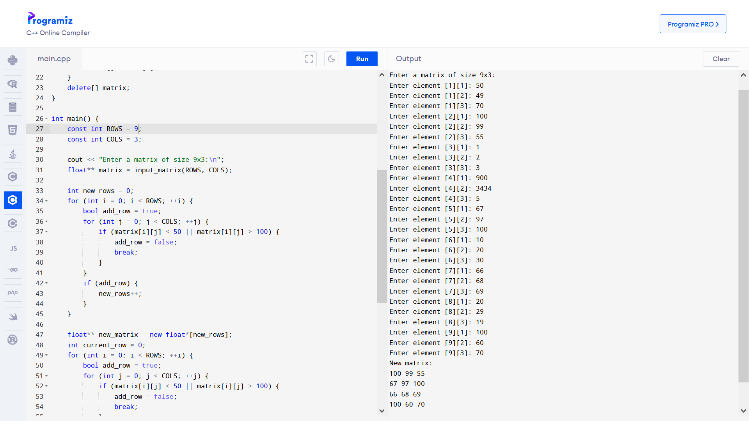

input_matrix

